TASK 5.2C

CLOUD COMPUTING

Creating a VPC Networking Environment for the Café

**Challenge 1: Set up Secure Admin Access & Internet Access for Private Instances**

**Task 1: Creating a Public Subnet**

* **Purpose:** Create a subnet that is connected to the internet.
* **Steps:**
  + Create a subnet (CIDR: 10.0.0.0/24) in **Availability Zone A**.
  + Create and attach an **Internet Gateway** to the Lab VPC.
  + Update the **Route Table** associated with this subnet to direct internet traffic (0.0.0.0/0) through the internet gateway.

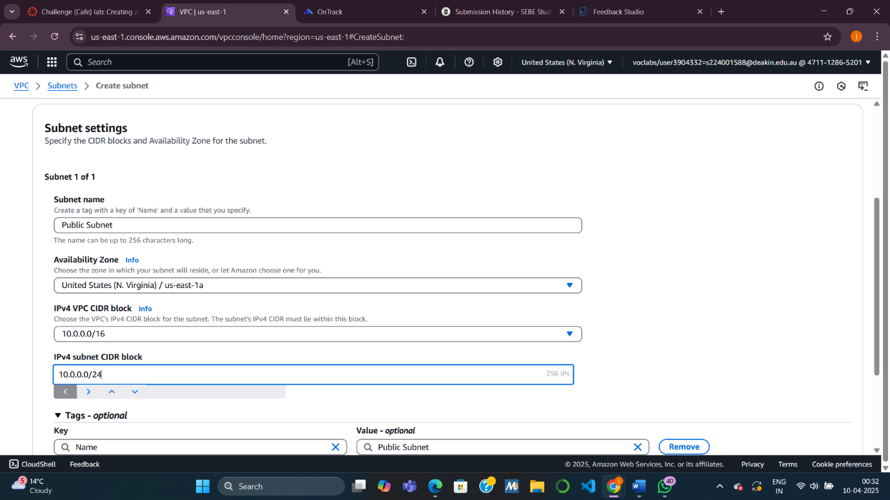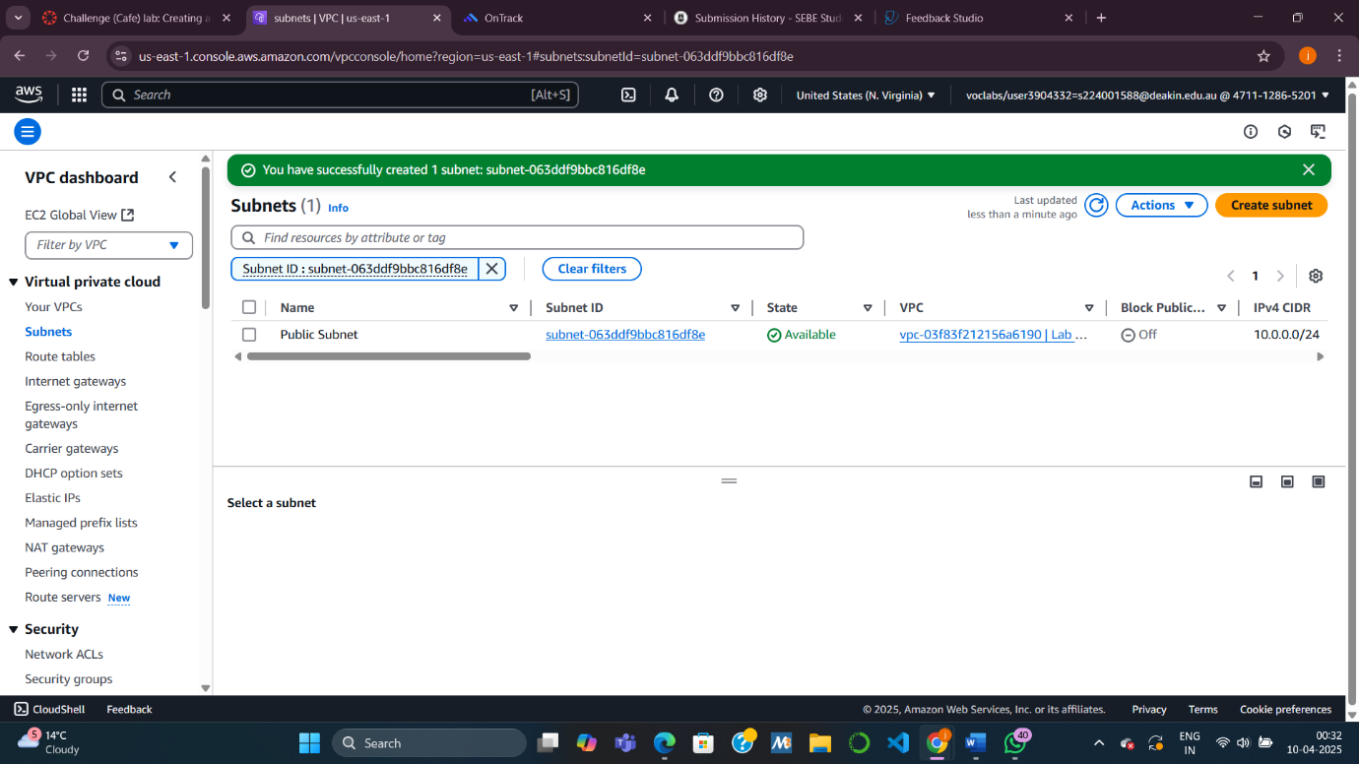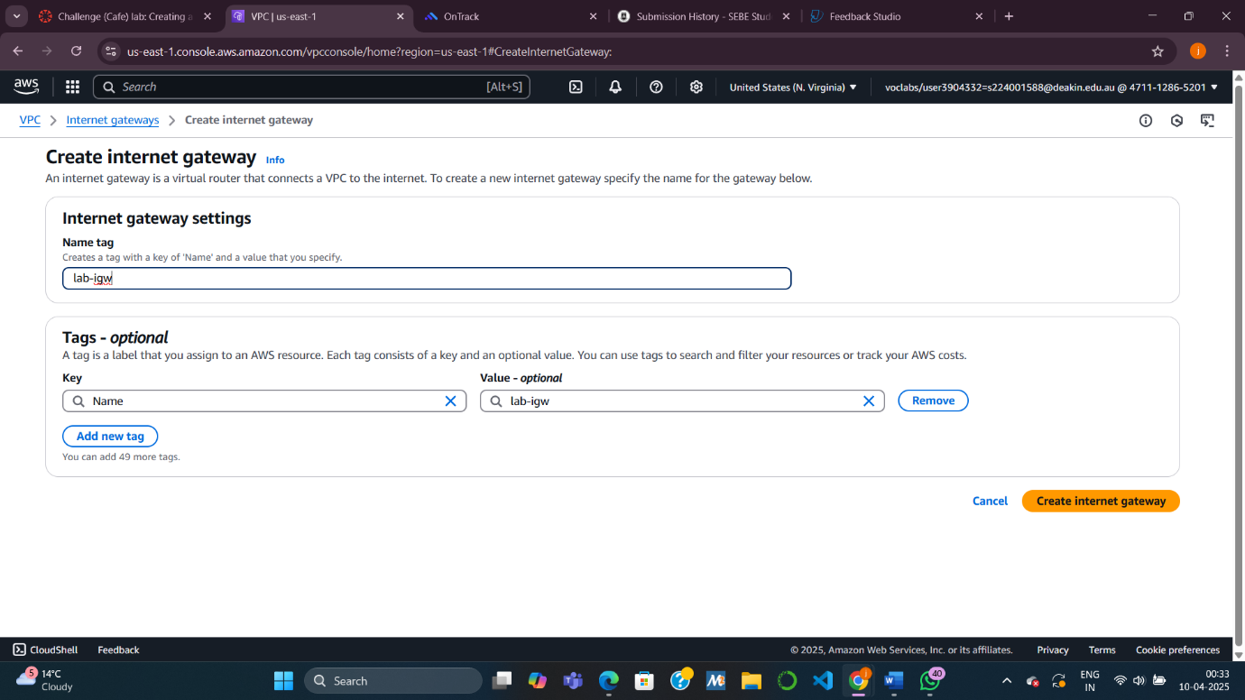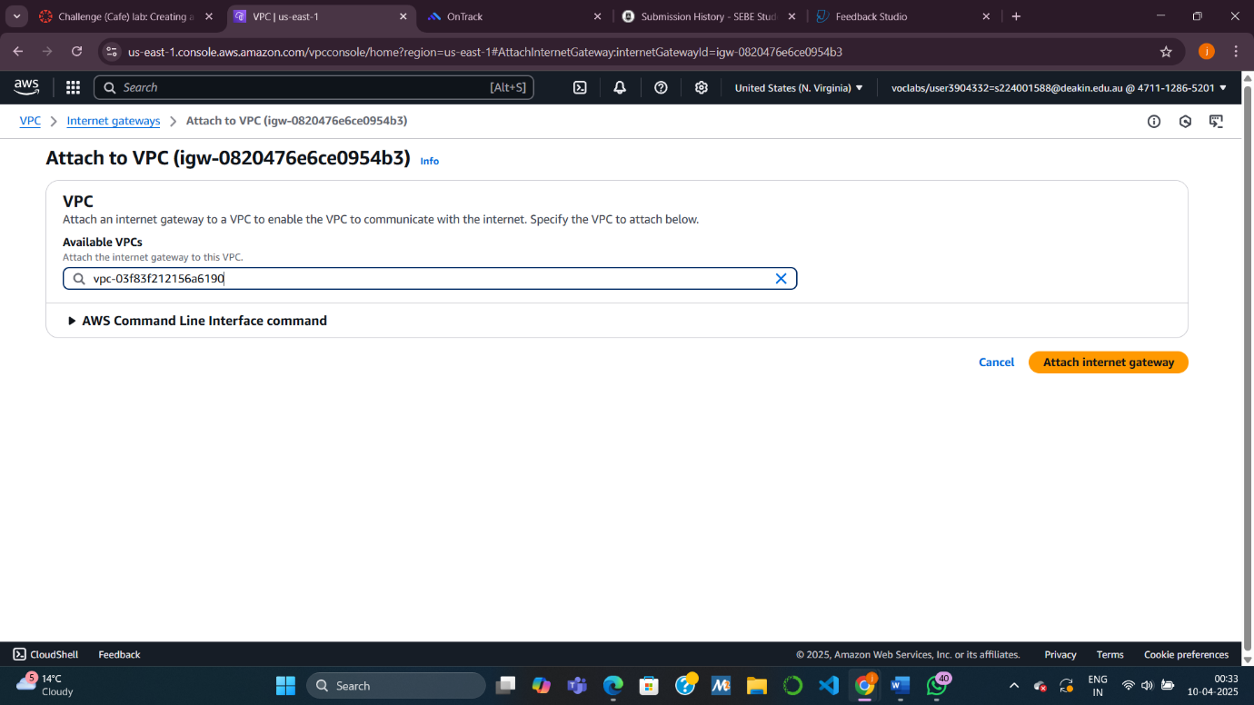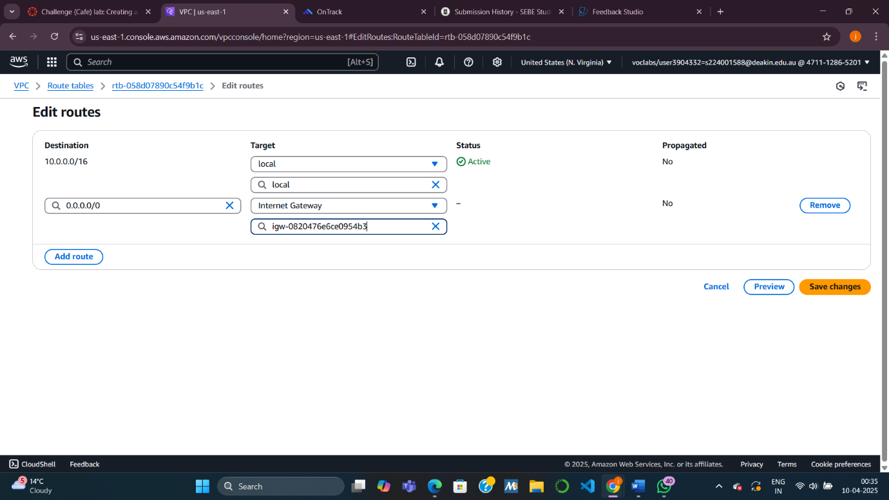

**Task 2: Creating a Bastion Host**

* **Purpose:** Set up a secure admin jump box for remote access to private instances.
* **Steps:**
  + Launch a **Linux EC2 instance** (t2.micro) in the public subnet.
  + Enable **public IP assignment**.
  + Create and assign a **Security Group (Bastion Host SG)** that allows **SSH (port 22)** access only from **your IP address**.
  + Use **Amazon Linux 2023 AMI** and key pair vockey.

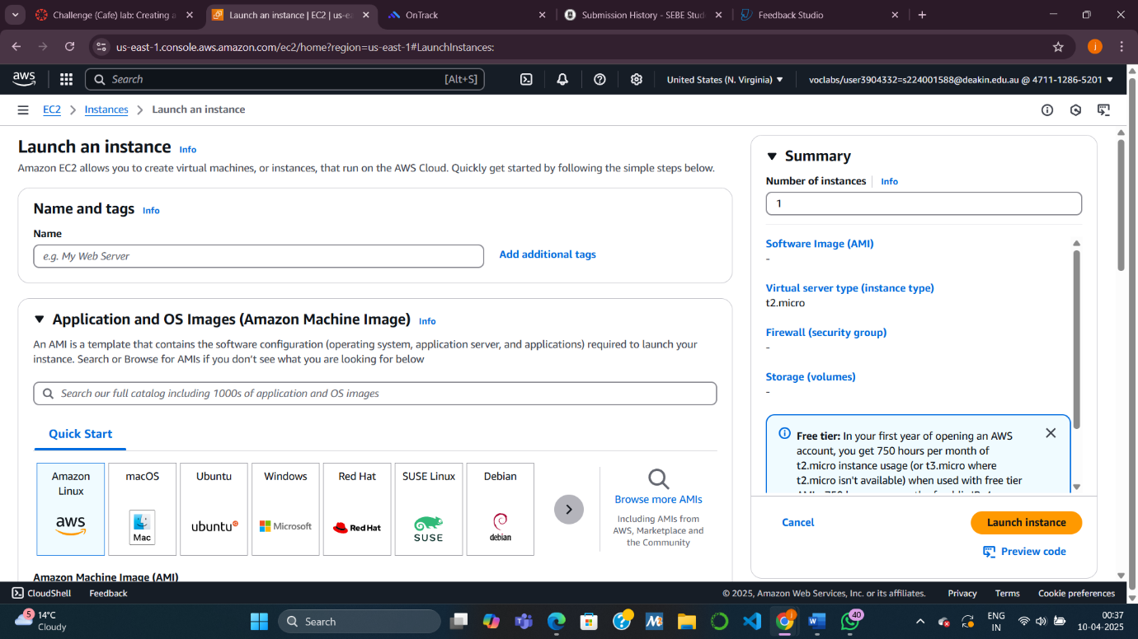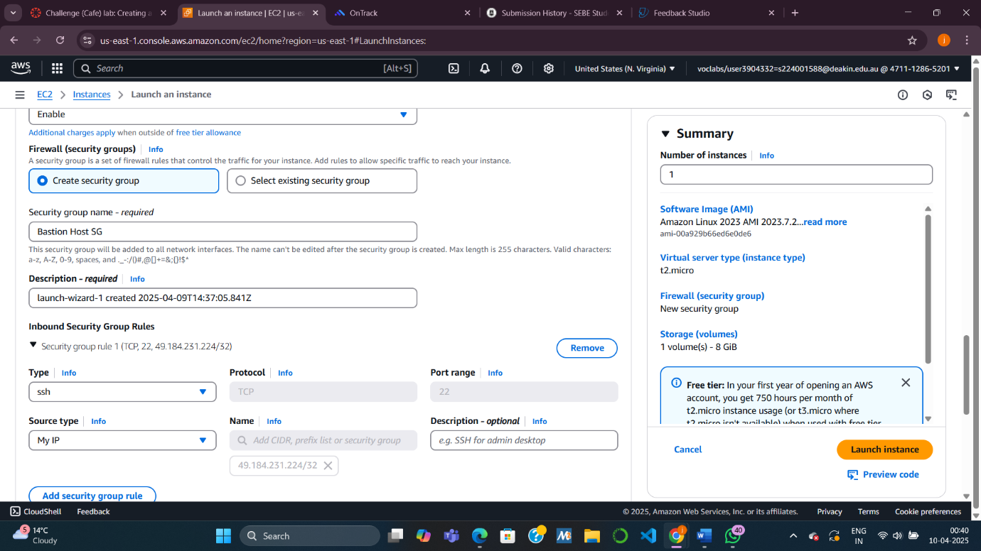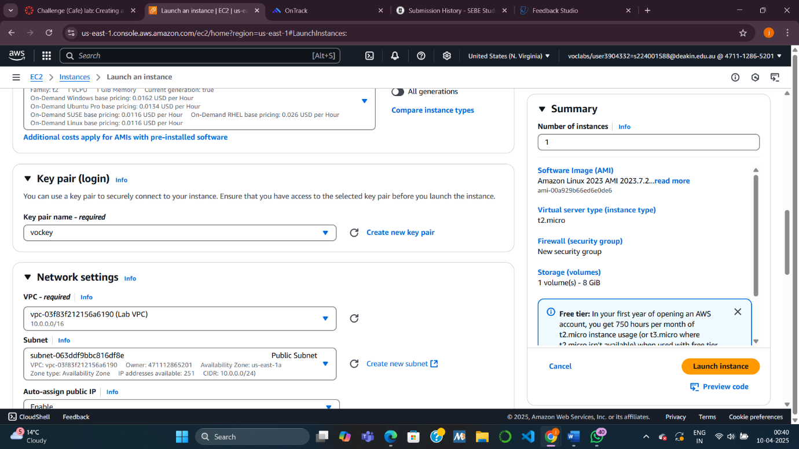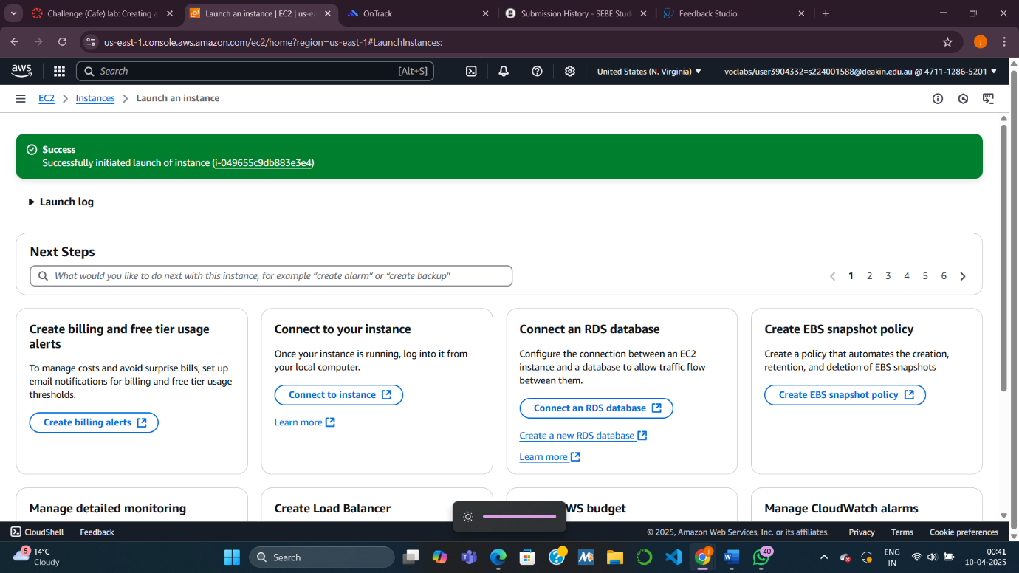

**Task 3: Testing the Connection to the Bastion Host**

* **Purpose:** Ensure you can remotely connect to the bastion host using SSH.
* **Steps:**
  + Download the appropriate SSH key (.pem or .ppk).
  + Use an SSH client (e.g., PuTTY or terminal) to connect to the Bastion Host.

**Task 4: Creating a Private Subnet**

* **Purpose:** Isolate internal resources from direct internet access.
* **Steps:**
  + Create a **new subnet (CIDR: 10.0.1.0/24)** in the same AZ as the public subnet.
  + Do **not** attach an internet gateway or enable public IP assignment.

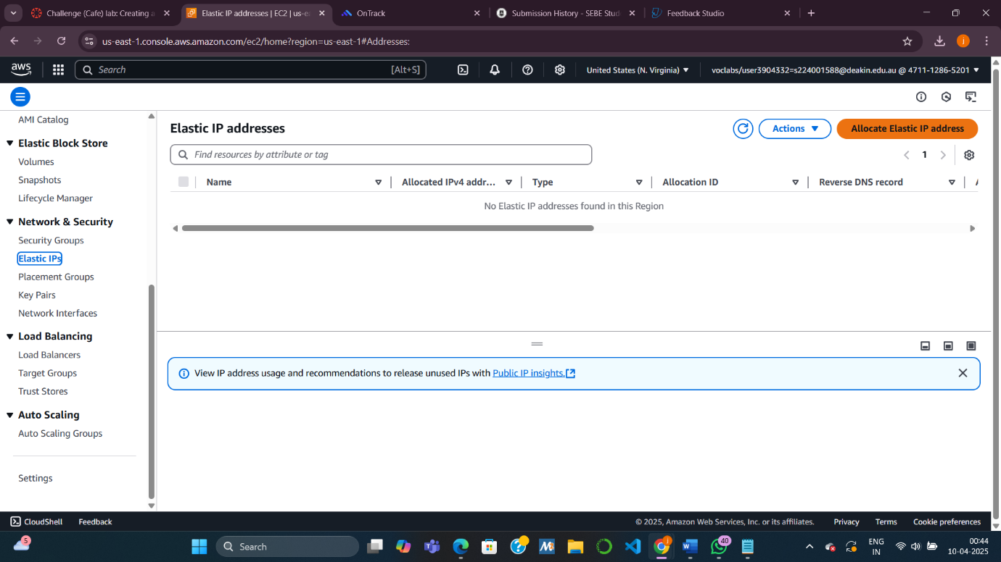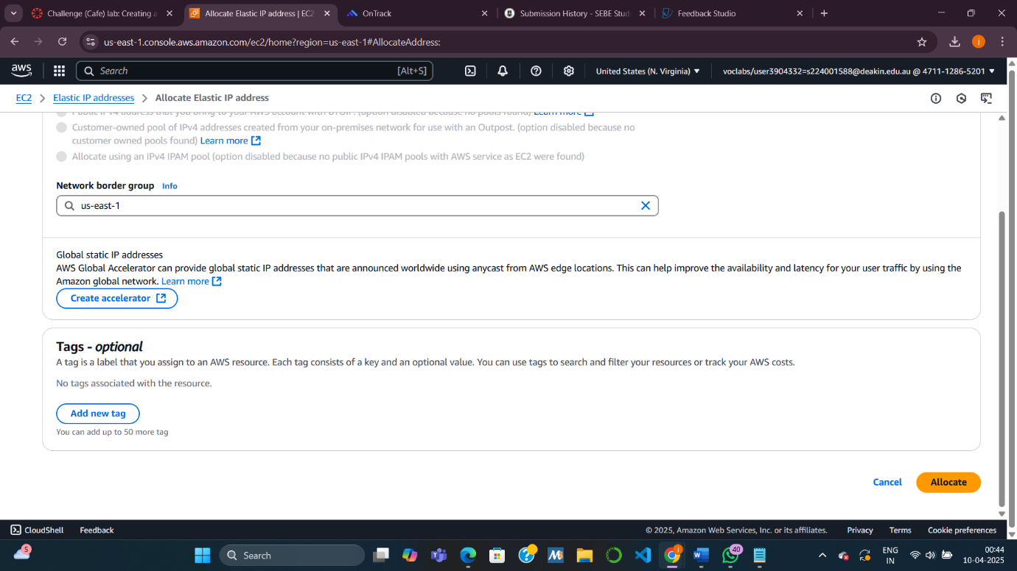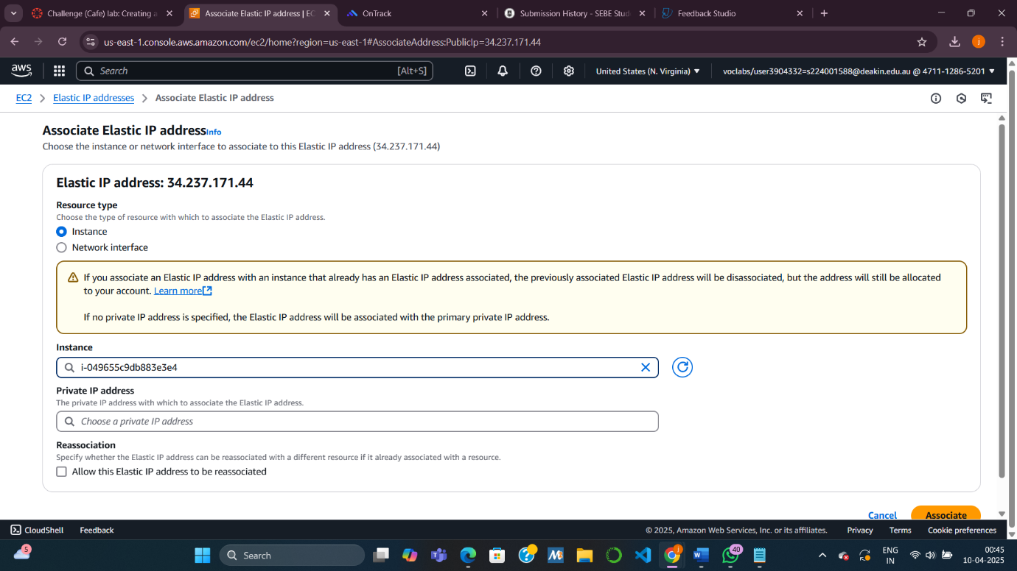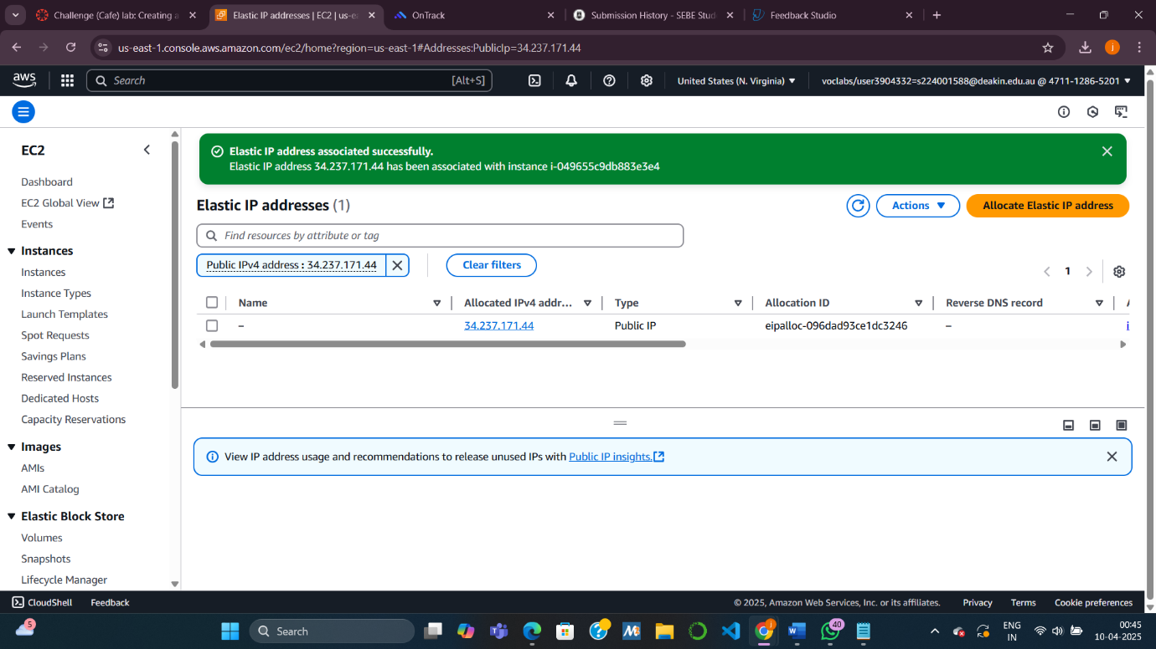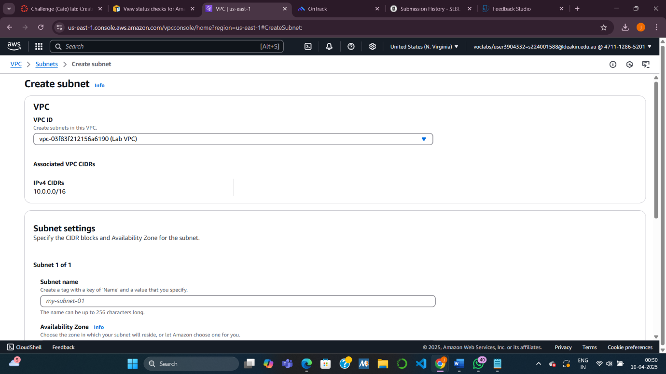

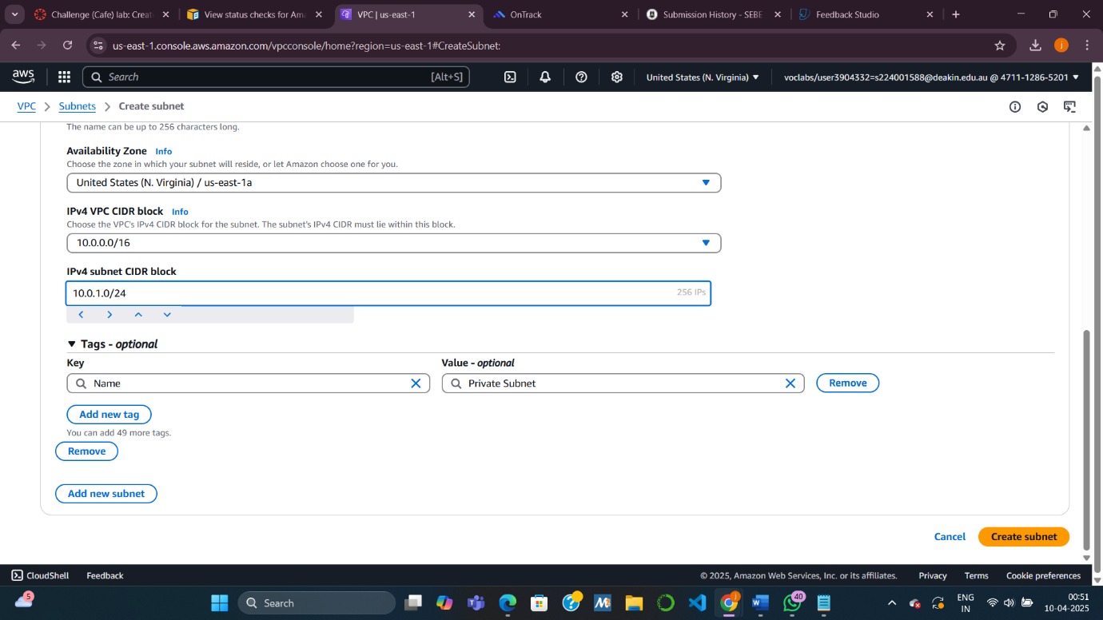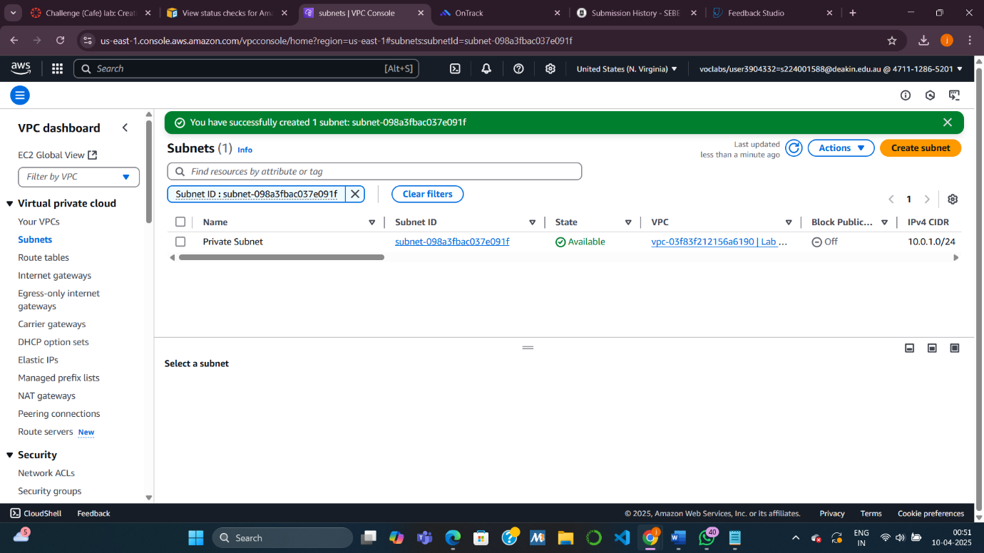

**Task 5: Creating a NAT Gateway**

* **Purpose:** Allow **outbound internet access** from private subnet instances (e.g., for updates).
* **Steps:**
  + Create a **NAT Gateway** in the **Public Subnet**, and allocate an **Elastic IP**.
  + Create a **new route table**, route all traffic (0.0.0.0/0) to the NAT Gateway.
  + Associate this route table with the **Private Subnet**.
* 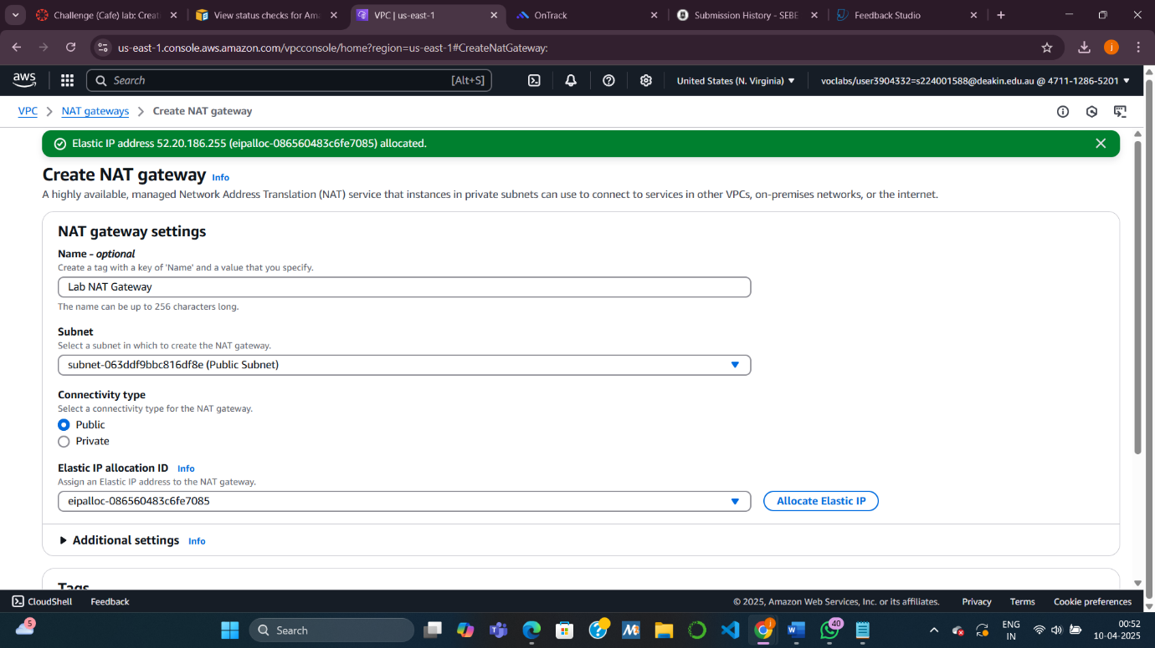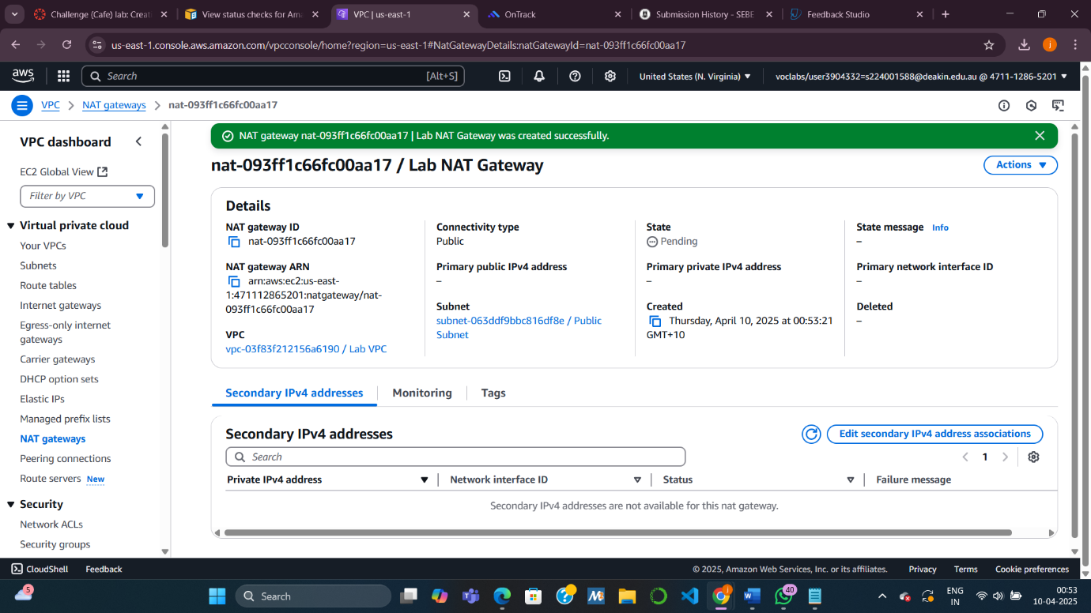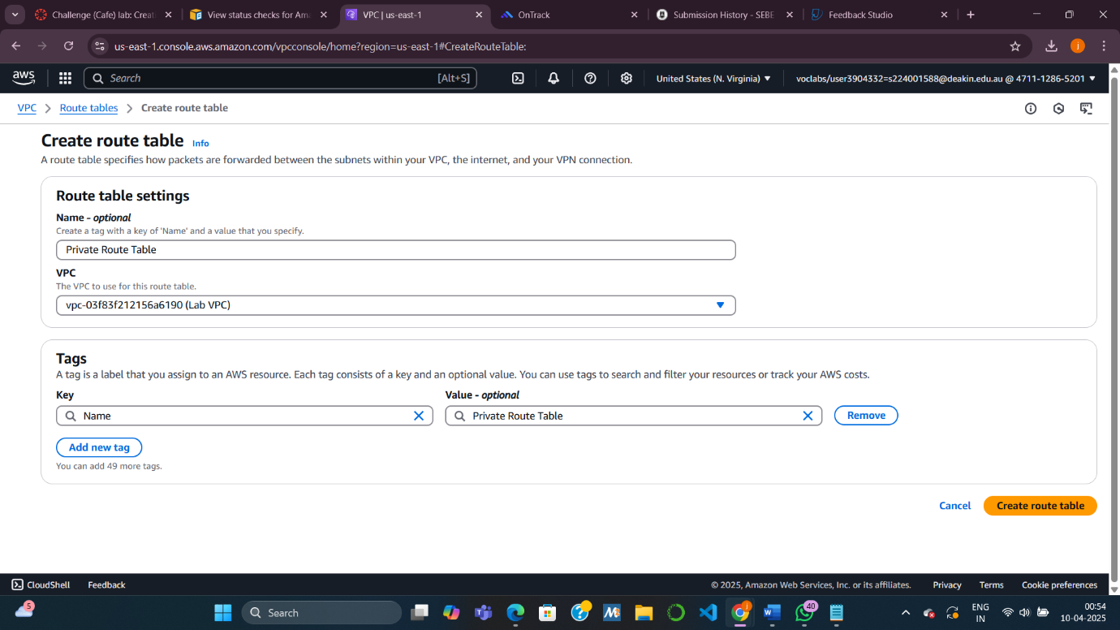
* 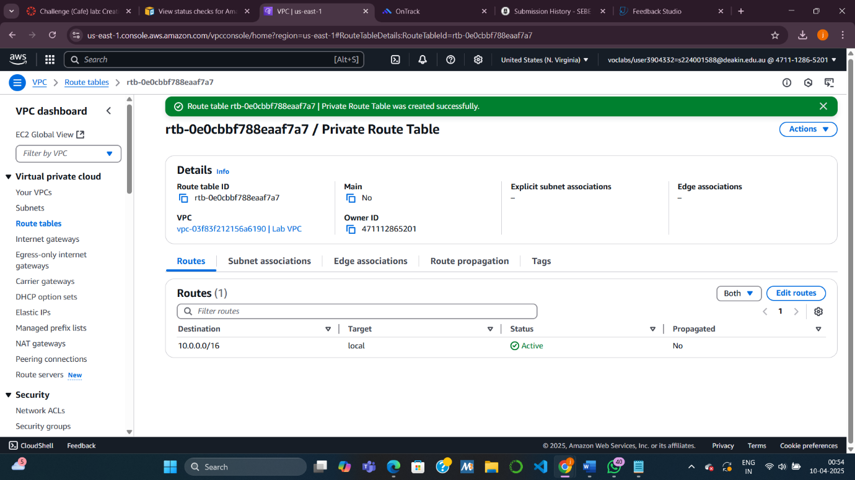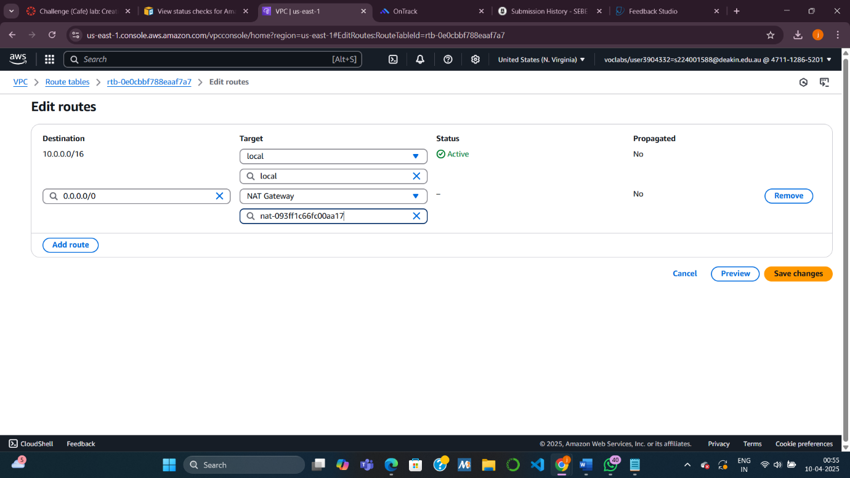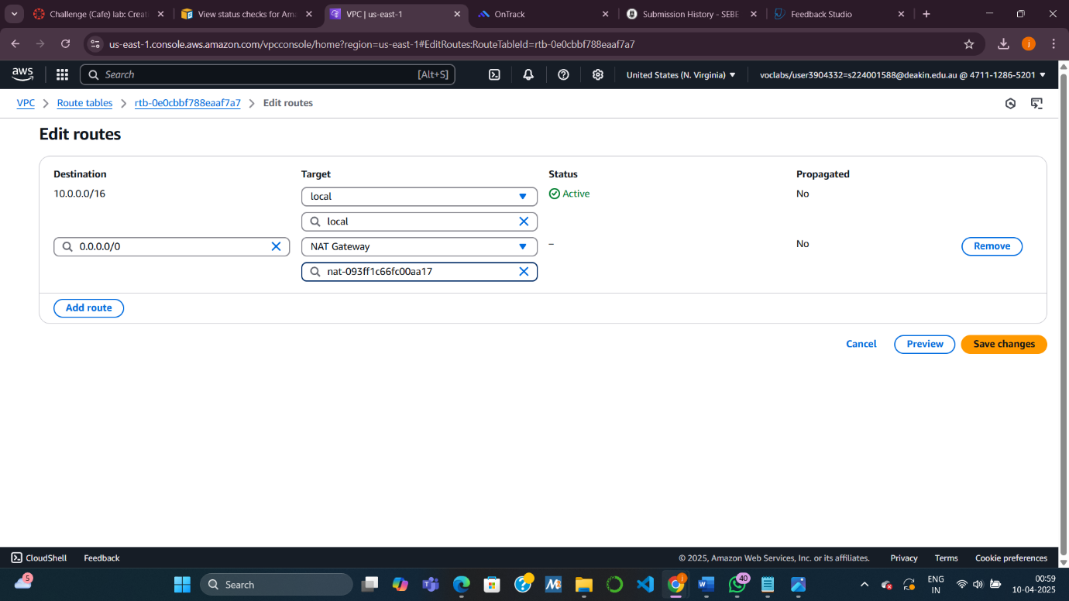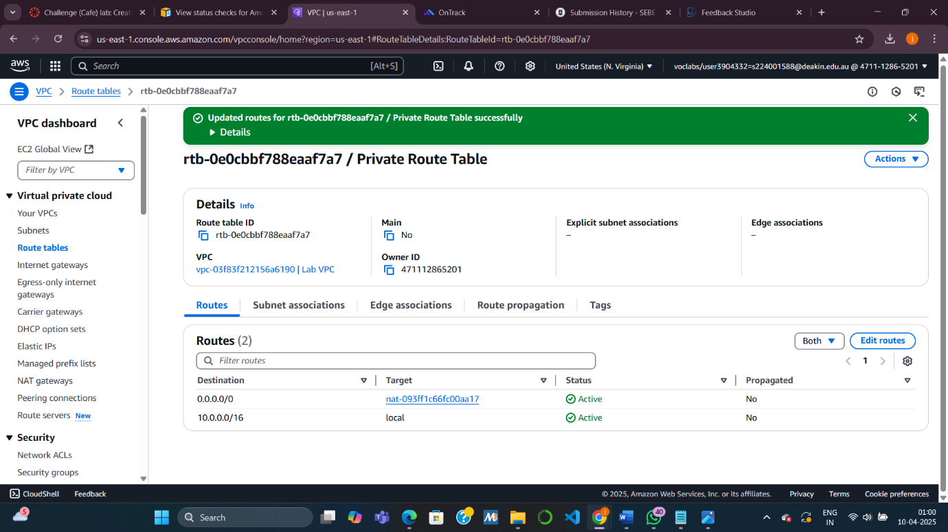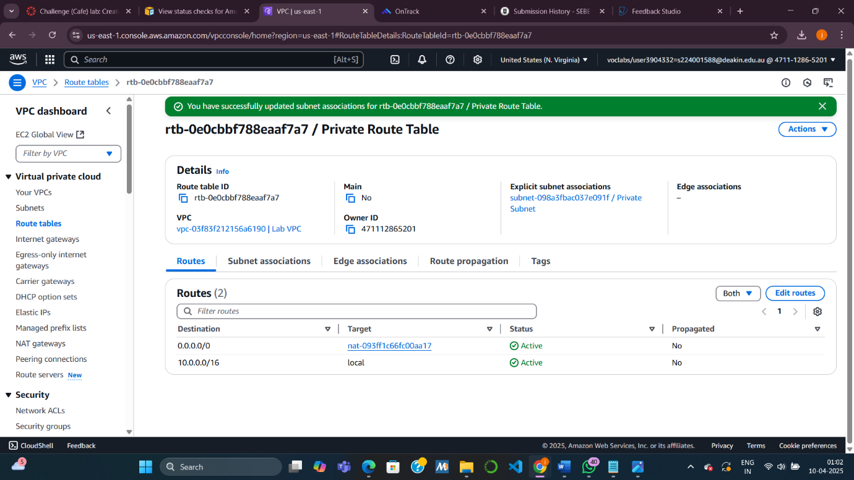

**Task 6: Creating an EC2 Instance in the Private Subnet**

* **Purpose:** Deploy a backend EC2 instance with no direct internet access.
* **Steps:**
  + Create a **new key pair** (vockey2).
  + Launch an **EC2 instance** (t2.micro, Amazon Linux 2023) in the **Private Subnet** using vockey2.
  + Create a **Security Group (Private Instance SG)** that allows **SSH (port 22)** only from the **Bastion Host SG**.

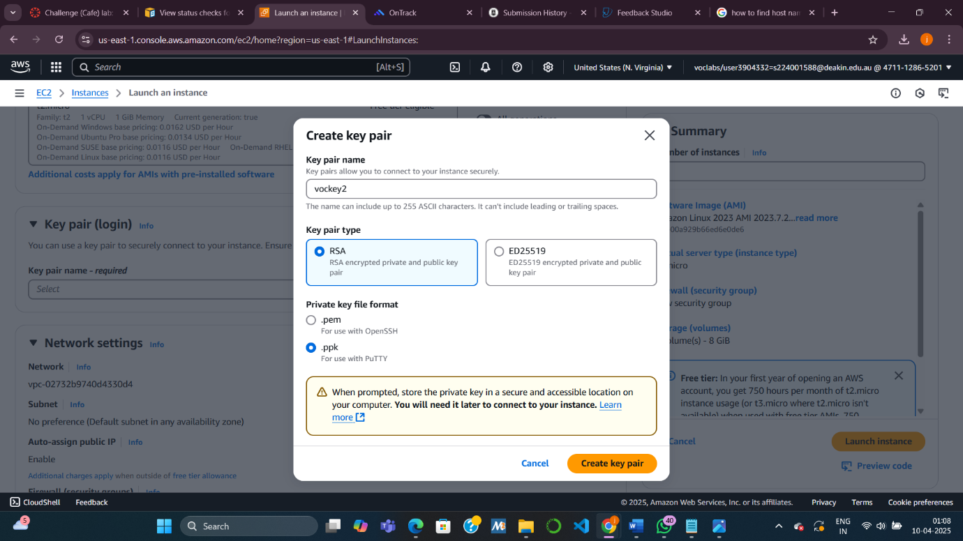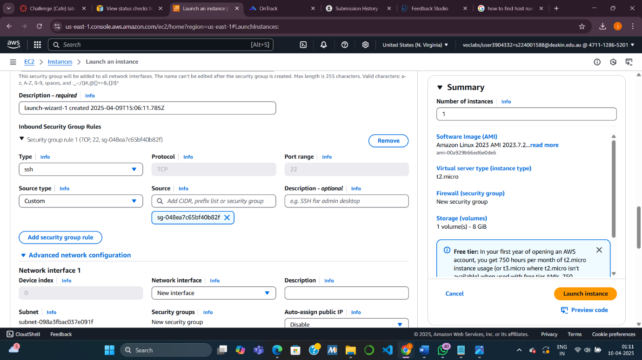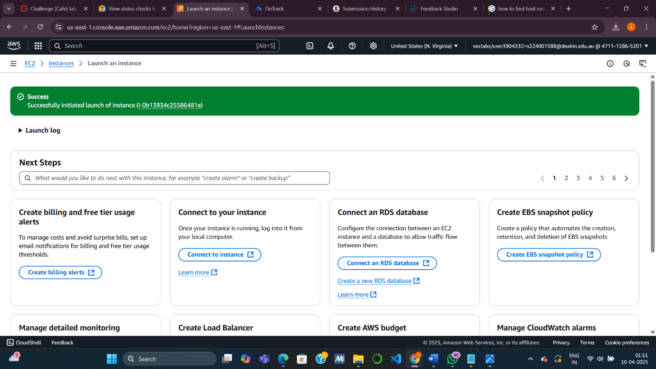

**Task 7: Configuring SSH Passthrough (Agent Forwarding)**

* **Purpose:** Access the private instance **through the Bastion Host** without copying key files.
* **Steps:**
  + **macOS/Linux:** Use ssh-add to load both vockey and vockey2 into the ssh-agent.
  + **Windows:** Use **Pageant** to load both .ppk files.
  + Enable **agent forwarding** so you can jump from Bastion Host to the Private Instance using the correct key.
* 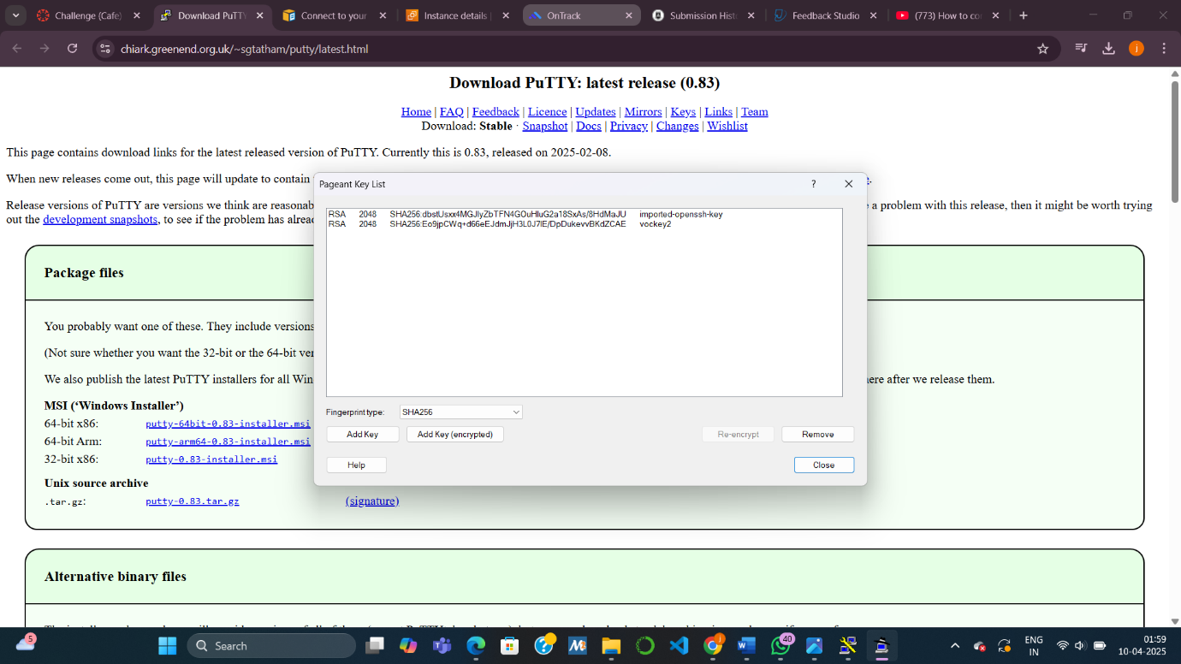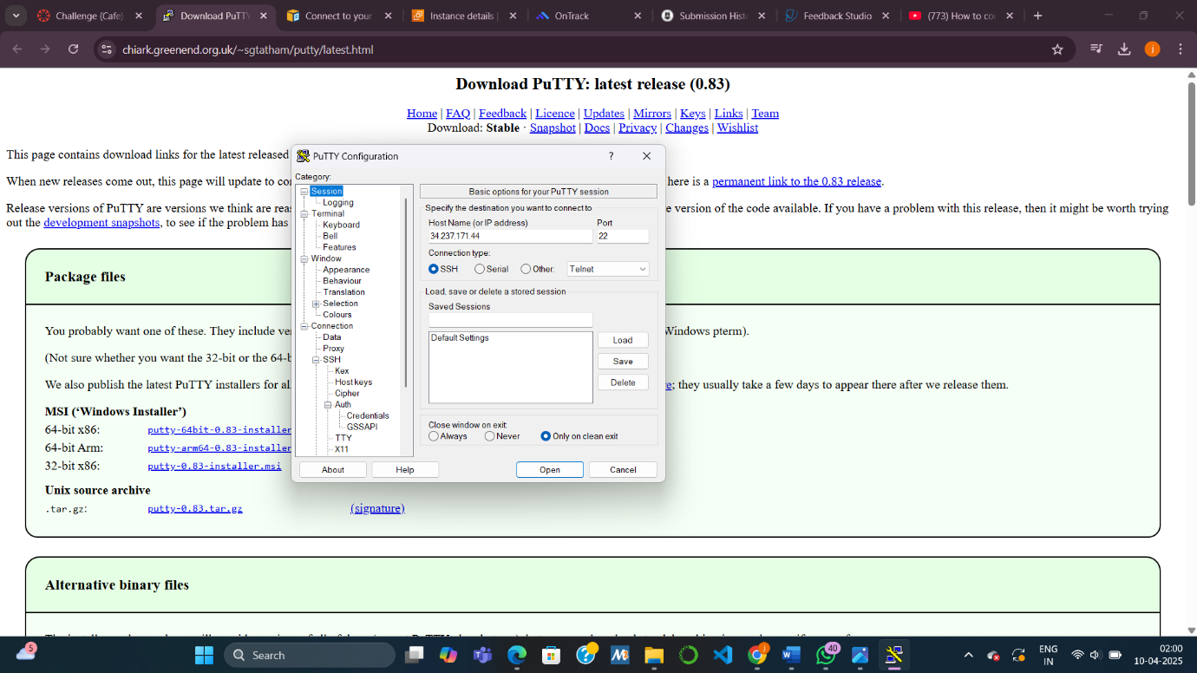

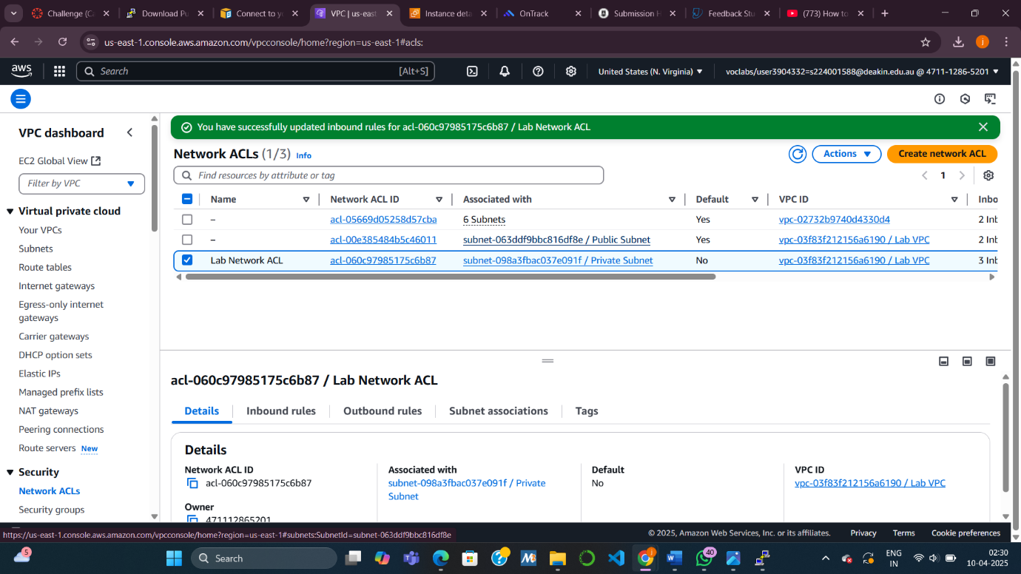

**Task 8: Testing the SSH Connection from Bastion to Private Instance**

* **Purpose:** Confirm successful passthrough SSH.
* **Steps:**
  + SSH to Bastion Host with agent forwarding enabled.
  + From there, SSH into the **Private EC2 instance** using its **private IP address**.
  + Test internet access from the private instance using ping 8.8.8.8.

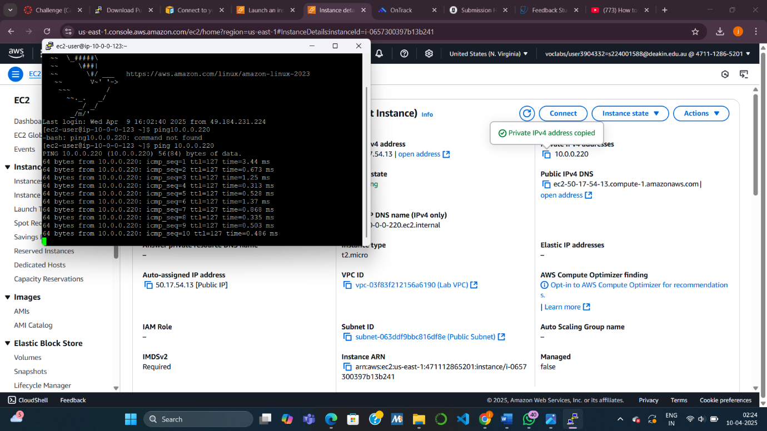

**🔒 Challenge 2: Implement Additional Security with Network ACLs**

**Task 9: Creating a Network ACL**

* **Purpose:** Add **another security layer** for the private subnet.
* **Steps:**
  + Create a **custom network ACL** (Lab Network ACL).
  + By default, all traffic is denied.
  + Add **inbound and outbound rules** to allow **all traffic** initially.
  + Associate this ACL with the **Private Subnet**.

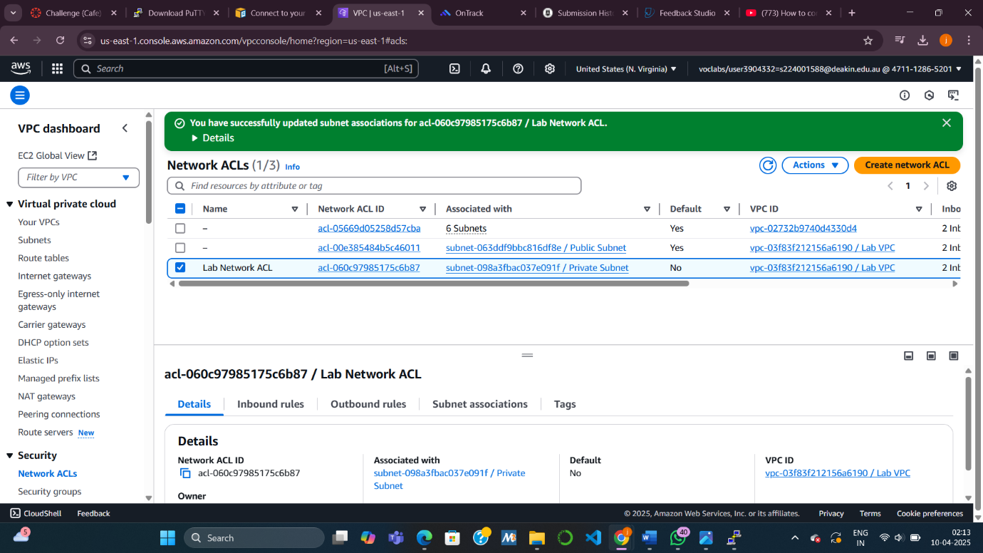

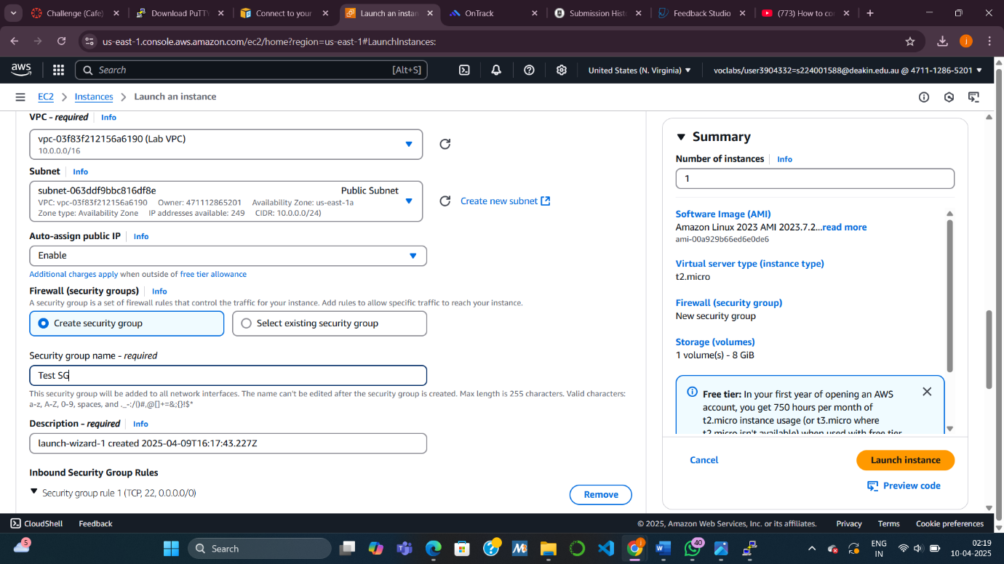

**Task 10: Testing Your Custom Network ACL**

* **Purpose:** Demonstrate control over subnet traffic with the custom ACL.
* **Steps:**
  + Launch a **Test EC2 instance** in the **Public Subnet** with ICMP (ping) enabled via its **Security Group**.
  + From the **Private EC2 instance**, ping the **Test Instance’s private IP** — it should respond.
  + Now **modify the ACL** to **deny ICMP IPv4** to the Test Instance’s private IP (/32).
  + Verify that ping **fails**, showing that traffic is blocked.

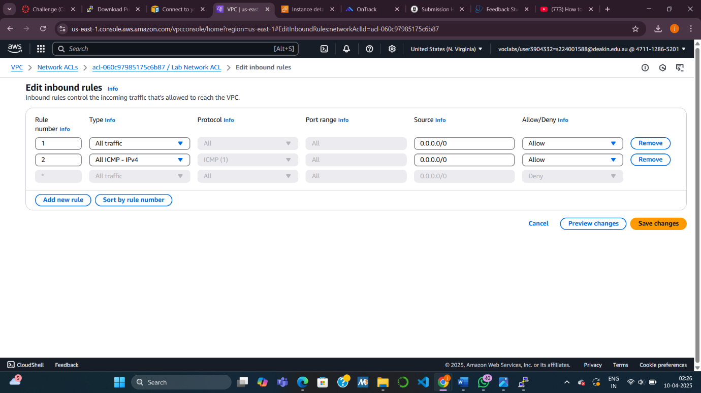

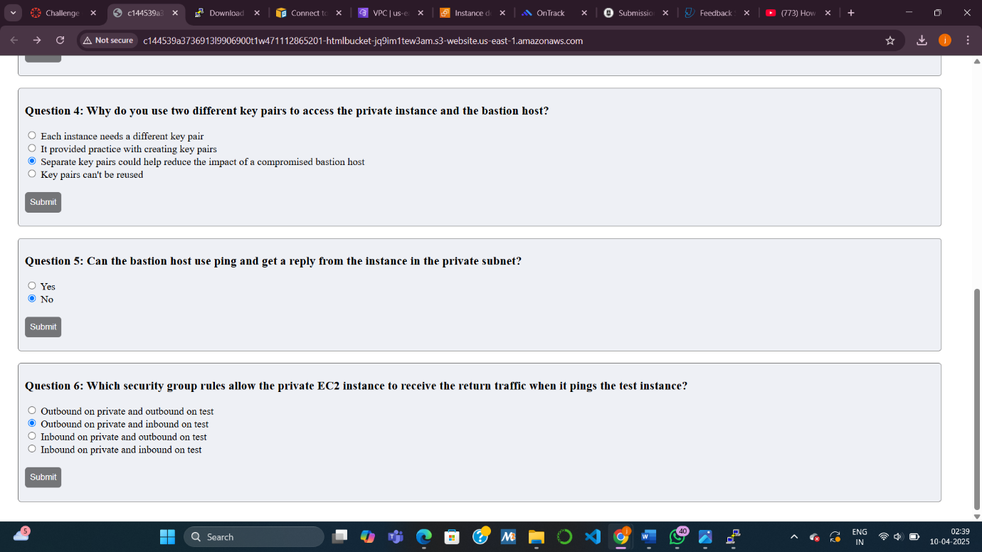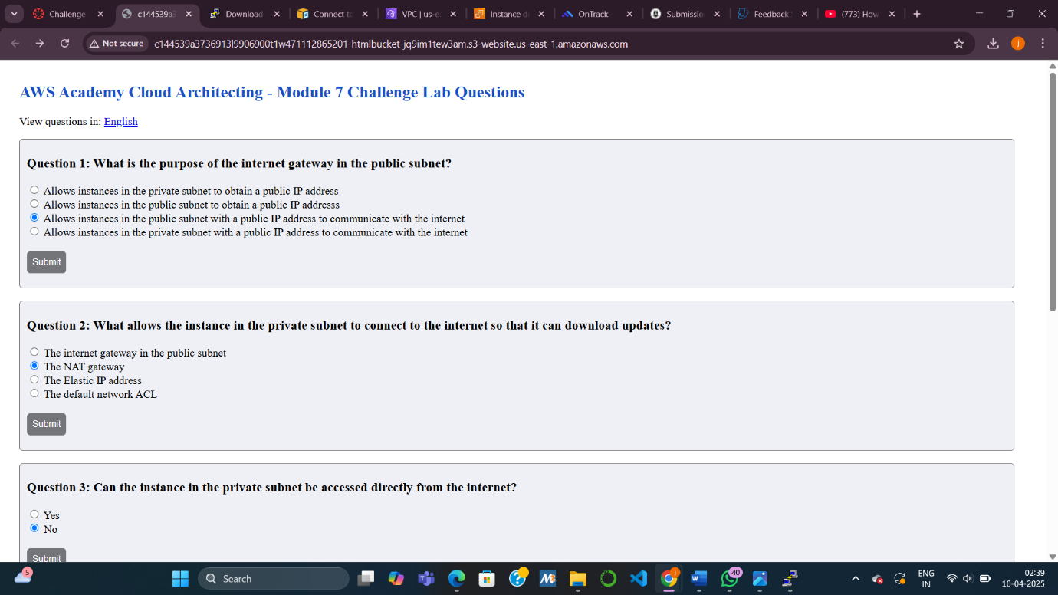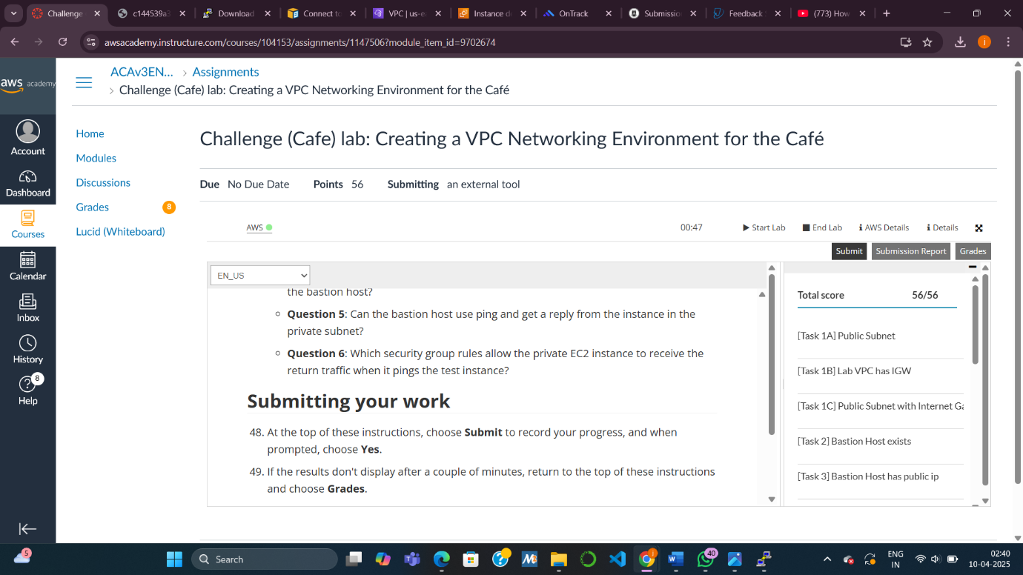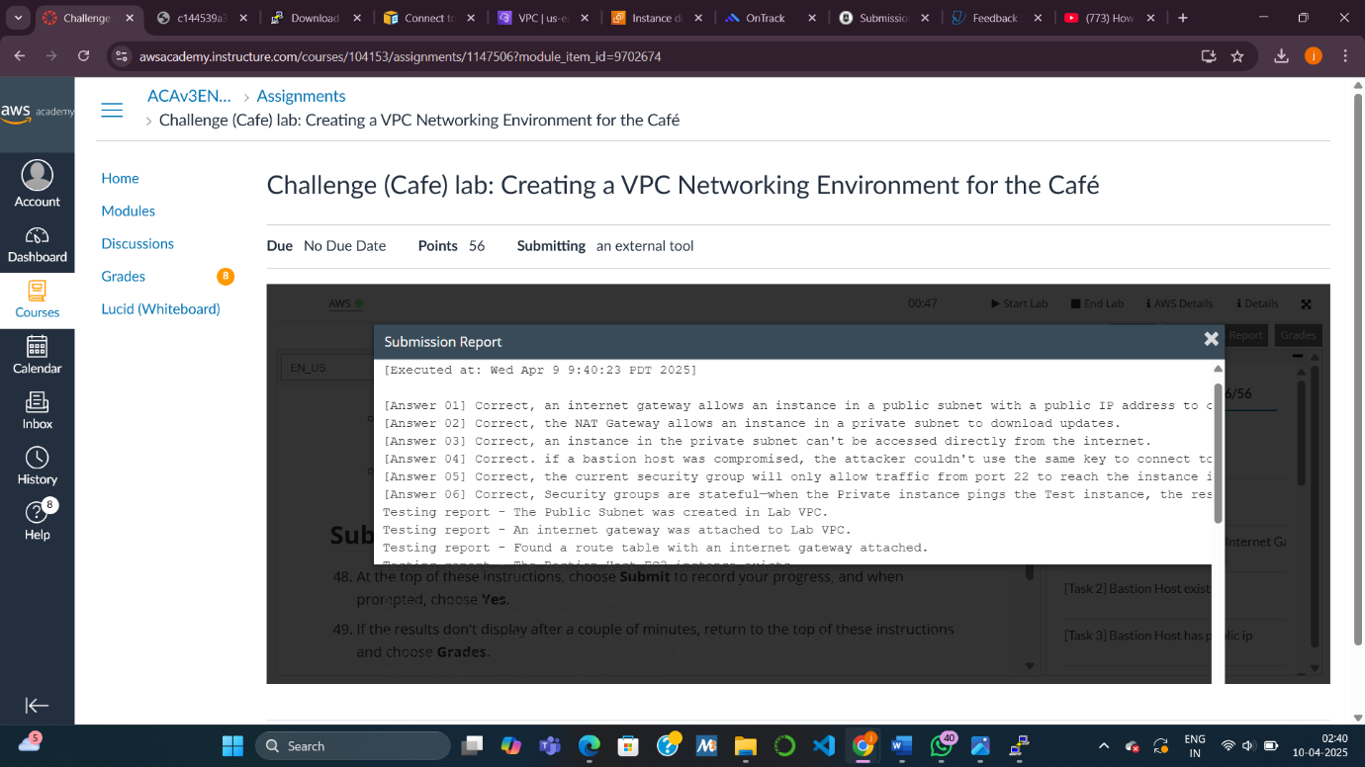

**What is the purpose of a Bastion Host?**  
To securely access private instances in a VPC by acting as a jump point from a public subnet.

**Why do we need an Elastic IP address?**  
To provide a **static public IP** for the NAT Gateway so that private instances can access the internet reliably.

**Why do we need to use SSH pass through in this lab?**  
To connect from your local machine → bastion host → private instance **without copying private keys** to the bastion host (enhances security using SSH agent forwarding).